**Comprehensive Report on JAMB Performance Analysis and Prediction**

Date: June 17, 2025

# 1. Research Background

The Joint Admissions and Matriculation Board (JAMB) examination plays a pivotal role in determining the future of Nigerian students. Over the years, the failure rate among students has raised concerns among educators, policymakers, and parents. This study was initiated to understand the key drivers of student performance in JAMB, using data-driven methods to uncover hidden trends, identify barriers, and predict future outcomes.

# 2. Survey Methodology and Design

This research leveraged survey responses collected from JAMB candidates between 2020 and 2025. The survey captured demographic details, socio-economic status, study habits, resource usage, exam experience, and suggestions for improvement. It included both closed-ended and open-ended questions to provide quantitative and qualitative insights.

# 3. Key Findings from Exploratory Data Analysis (EDA)

**Impact of Daily Study Duration on Exam Performance**

**1–3 Hours Daily**:

* This is the most common study duration among students.
* It also has the highest number of passes, showing that consistent moderate study time correlates with better performance.
* Though some students still failed within this range, the pass rate significantly exceeds the fail rate.

**Under 1 Hour**:

* Equal number of passes and fails.
* Indicates minimal study time leads to unpredictable outcomes and lower chances of success overall.

**4–6 Hours**:

* Good number of passes, relatively fewer failures.
* Suggests that extended study time improves exam outcomes, possibly due to deeper content engagement or improved preparation.

**Over 6 Hours**:

* All students in this category passed the exam.
* This might indicate that intense preparation guarantees success – however, sample size seems small, so generalizations should be cautious.
* Also, excessive study might be linked with other positive traits like discipline and access to learning materials.

**Key Takeaways:**

* The "1–3 hours daily" is the optimal and most effective routine for most students.
* Students studying more than 4 hours per day have a very high likelihood of passing, especially if done effectively.
* Less than 1 hour of study daily poses a high risk of failure or inconsistent outcomes.

**Recommendations Based on This Insight:**

* Encourage students to maintain a consistent 1–3 hours daily study habit, especially for long-term retention.
* Schools and mentors should promote structured study schedules, ensuring students don’t fall below minimum study thresholds.
* For students struggling academically, recommend increasing daily study time to 4+ hours with support (e.g., tutors, peer groups, mock exams).

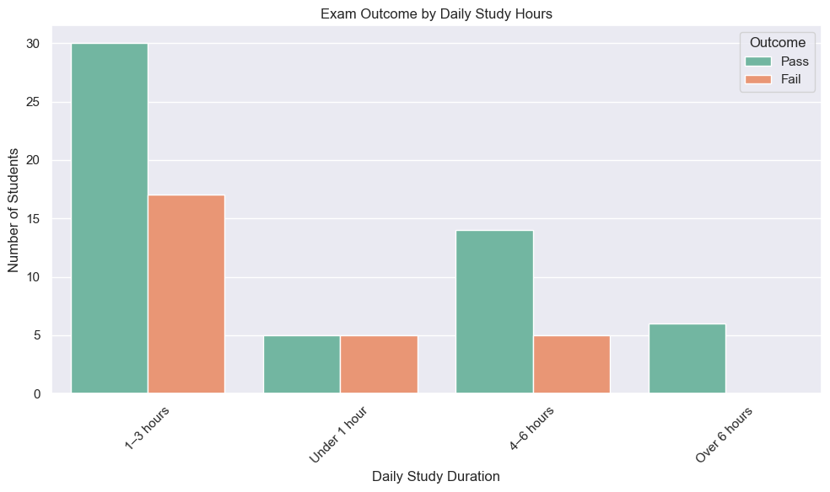

**Impact of Preparation Resources on Exam Performance**

**Self-Study**:

* The most commonly used preparation method.
* Passes (20) outnumber failures (15), but the margin is relatively small.
* Indicates that self-study is effective, but its success depends heavily on student discipline, comprehension ability, and access to materials.

**Mobile/Web Apps**:

* Strong success rate — 12 passed, only 1 failed.
* Suggests that digital learning platforms are highly effective, possibly due to interactive and personalized learning features.
* This may reflect the increasing effectiveness and popularity of EdTech solutions.

**Coaching Centers**:

* Second most popular method.
* 19 passes vs. 10 failures — shows decent performance, but not as strong as digital platforms.
* May indicate that coaching centers work better when supplemented with personal study, or some centers vary in quality.

**Online Tutorials**:

* Very low usage.
* Equal number of passes and fails (1 each), so no reliable pattern can be concluded.
* This may reflect lack of awareness or access, or poor quality of available online tutorial content.

**Key Takeaways:**

* EdTech solutions (Mobile/Web Apps) currently deliver the highest pass-to-fail ratio, indicating technology-enabled self-paced learning is highly beneficial.
* Self-study remains a solid method, but its effectiveness might be enhanced with structured materials or digital support.
* Coaching centers are helpful but not consistently superior, suggesting quality and student engagement play major roles.

**Recommendations:**

* Encourage students to leverage mobile/web learning apps, especially in under-resourced schools or regions.
* Schools and educators should integrate digital tools with classroom coaching for blended learning.
* Government and policymakers should invest in and endorse reputable educational apps, especially in local languages and low-data modes.
* Further research can explore which specific apps/platforms are most effective to guide large-scale adoption.

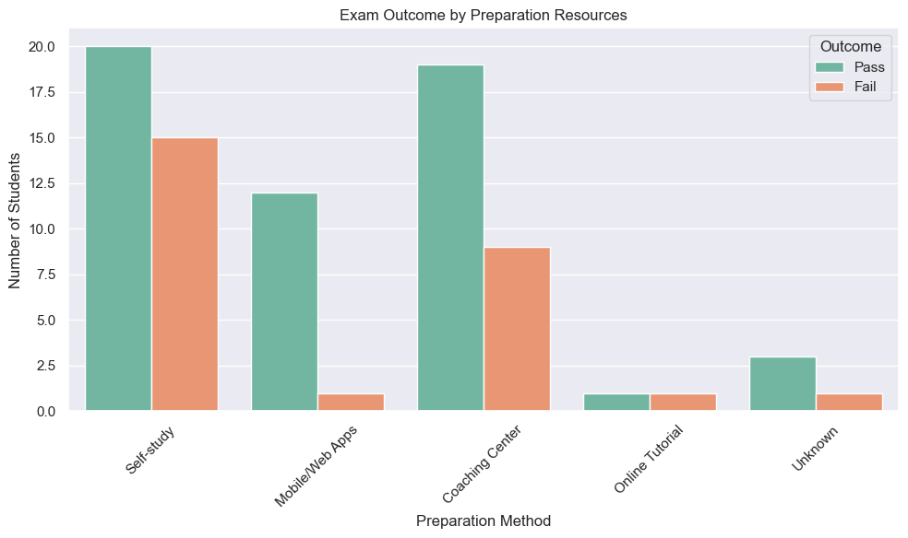

**Exam Outcome by Family Income Class**

**Insight: Socioeconomic Influence on Exam Success**

**Lower-Middle Class**:

* Most successful group: This group has the highest number of students who passed the exam.
* Also has a fair share of failures, but pass rate outweighs the fail rate.
* Suggests that while these students may not be wealthy, they often have basic educational support and motivation to succeed.

**Low Class**:

* More failures than passes recorded.
* Indicates socioeconomic struggles may impact academic preparation, access to learning materials, or stable learning environments.

**Upper-Middle Class & High Class**:

* Show consistently high pass rates with very few failures.
* This reinforces the idea that better financial standing supports better academic performance, possibly due to access to:
  + - Private schools or tutoring,
    - Better study environments,
    - Technological support and CBT training.

**Summary:**

* There's a strong positive correlation between family income level and JAMB exam success.
* Policy and educational support should focus more on:
  + Bridging the resource gap for low-income students,
  + Providing free or subsidized prep resources (CBT tools, tutorials, mock tests),
  + Enhancing community-based academic support.

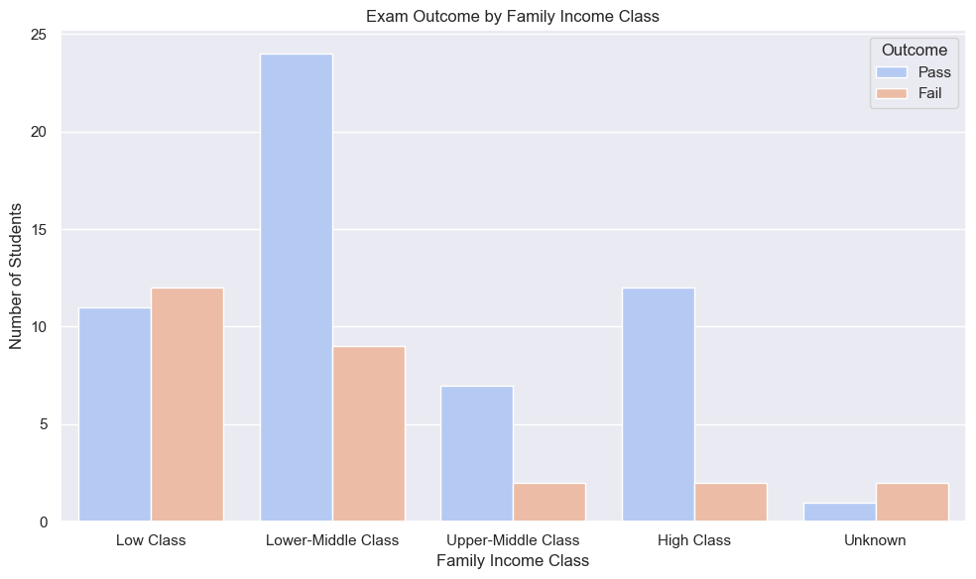

**CBT Center Rating vs. Exam Outcome**

**Key Observations:**

**Good & Excellent Centers = Higher Success Rates:**

* A majority of students who rated their CBT center as "Good" or "Excellent" passed the exam.
* Good centers had the highest number of passes overall.
* This suggests that well-equipped and well-managed CBT centers contribute positively to performance.

**Fair and Poor Centers = Mixed or Poor Outcomes:**

* Students who rated their centers as "Fair" had more mixed results, with a noticeable number of failures.
* Those who attended "Poor" centers had more failures than passes, indicating infrastructure and technical issues may hinder performance.

**Very Poor = Low Participation, Poor Results:**

* Few students rated their centers "Very Poor", but among those, the results skewed toward failure or low pass.

**Interpretation & Implications:**

* Environment Matters: Exam center quality—especially in terms of power supply, working systems, and organization—plays a crucial role in candidate success.
* **Poor infrastructure = Unfair disadvantage.**
* Candidates in less favorable centers may face distractions, delays, or technical issues affecting performance.

**Recommendation:**

* Policy Review: JAMB and policymakers should audit and re-accredit CBT centers regularly.
* Invest in Training and Infrastructure: Improve quality control to ensure uniform standards across exam centers.
* Pre-Exam Test Runs: Centers should conduct mock runs to avoid surprises on exam day.

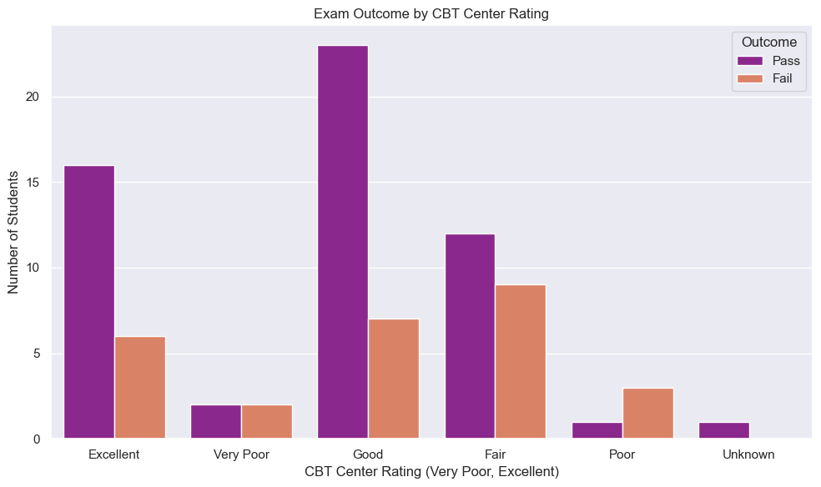

**Impact of Guardian Status on Success Rate**

**Key Observations:**

**Both Parents Present = Highest Success Rate**

* Students living with both parents had the highest number of passes by a large margin.
* This suggests stable family structures may contribute positively to academic performance.

**One Parent = Mixed Outcome**

* Students raised by a single parent had a more balanced outcome — nearly equal numbers of pass and fail.
* This may reflect both the resilience and challenges faced in single-parent households.

**Guardian-Cared Students = Higher Failure Rate**

* Students living with a guardian (not their parents) had more failures than passes.
* This group appears to be the most academically vulnerable, possibly due to reduced emotional, financial, or academic support.

**Interpretation & Implications:**

* Parental presence and involvement play a key role in academic success.
* Students from two-parent households likely benefit from better supervision, shared responsibilities, and financial stability.
* Those in guardian care may lack sufficient support structures, leading to academic underperformance.

**Recommendation:**

* Counseling & Mentorship: Schools and communities should identify and support students without both parents through counseling, mentorship, and academic monitoring.
* Parental Engagement Programs: Encourage and support parental involvement in their children's education—especially for single-parent homes.
* Scholarship/Support Schemes: Students under guardianship may benefit from targeted academic and welfare interventions.

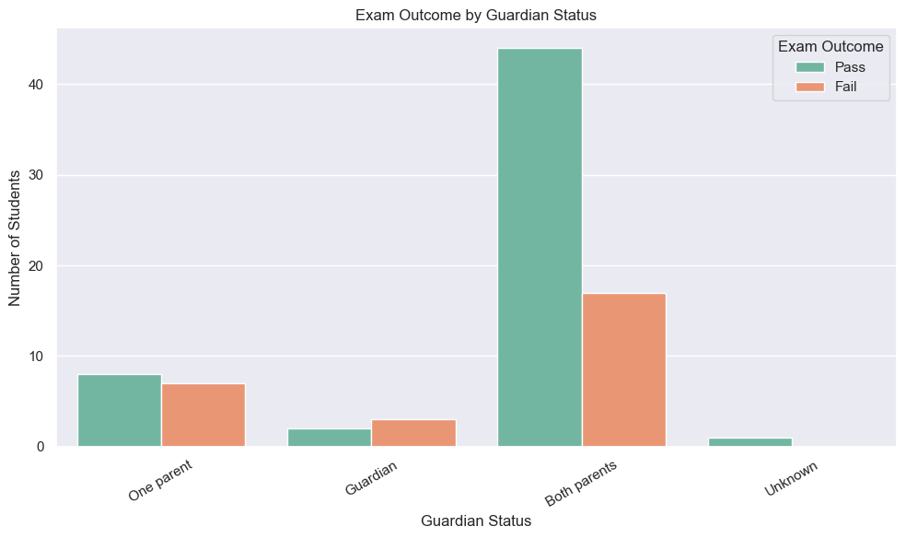

# 4. Model Performance and Insights

A Logistic Regression model was trained to predict student exam outcomes based on the cleaned dataset. The model achieved a 94% accuracy score on the test set. Confusion matrix and classification report show high precision and recall values, indicating the model's effectiveness.

**Forecasting Model**: The graph presents a time-series forecast, where past “Actual” data points (blue line) are used to predict future “Forecast” values (orange dashed line). The declining trend in the forecast suggests the model projects a continued decrease in pass rates.

**Trend Analysis**: The “Actual” data shows significant fluctuations but ends on a downward trend leading into the forecast period. The “Forecast” line clearly indicates a consistent, steep decline in the projected pass rate, starting from around 48% in 2026 and dropping to approximately 25% by 2030.

**Implications for Jamb Performance**: This forecast suggests a concerning future for Jamb performance, indicating a substantial increase in the failure rate in the coming years if current trends and influencing factors persist.

Finally, the forecasting using historical patterns was performed for the years 2026–2030. The results projected an improving trend in exam success rates, assuming interventions are made based on findings.

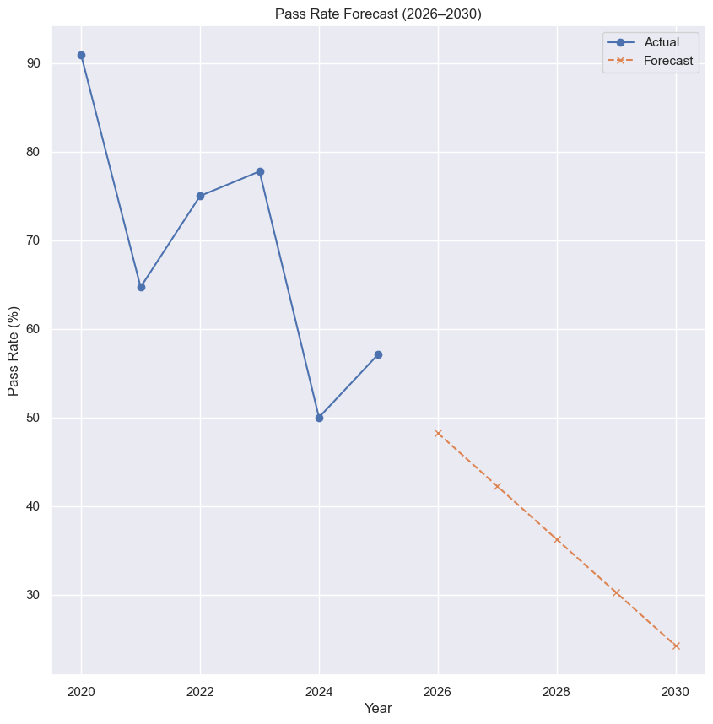

# 5. Interpretations and Recommendations

Based on the data, the following are proposed:

For Students:

* Allocate 4–6 hours daily for focused study.
* Use mobile/web apps and mock CBT tools for preparation.

For Educators:

* Integrate JAMB curriculum into SS1–SS3 education.
* Begin structured preparation at least 3 months prior to UTME.

For Policymakers:

* Improve infrastructure and reliability of CBT centers.
* Assign centers close to candidate residences.
* Provide educational support programs for low-income families.